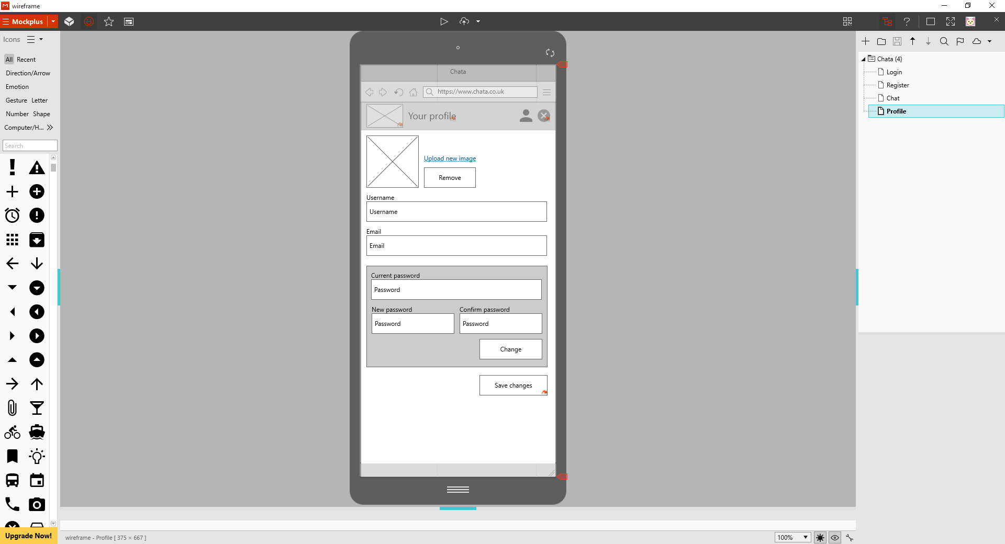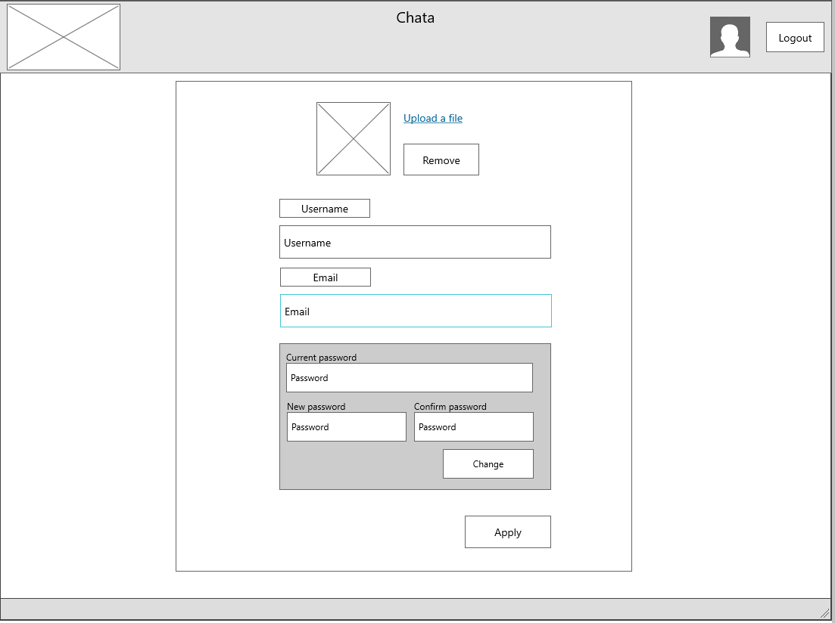

The ‘Your Profile’ Wireframe

* The new password and confirm password inputs may be too small to fit the user’s full password in when on a mobile device. Having them on separate rows, making them full width would then stop this from happening.
* If the upload file (image) function is centred at desktop, it could be centred in mobile and vice versa
* Simplicity works well, allowing no confusion or uncertainty.

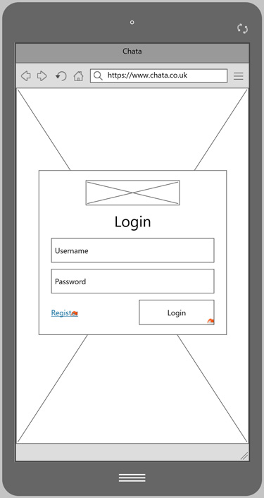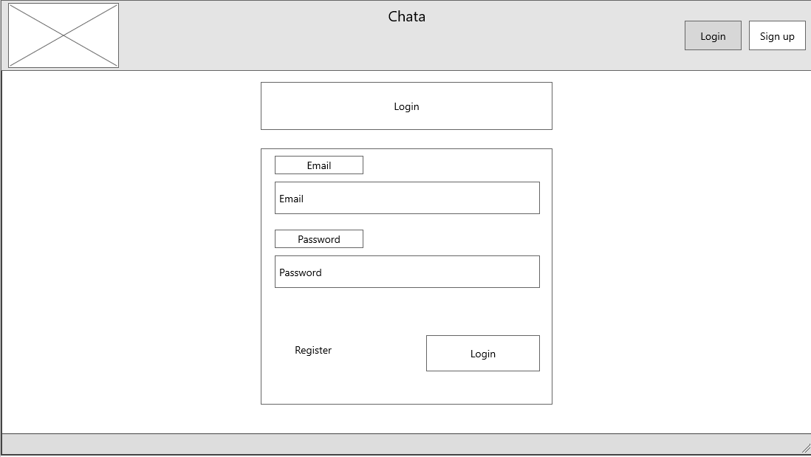

* The Login Screen will need a forgotten password link to allow users to reset their password if forgotten.
* Again the simplicity works well as it shows the full range of the functions. This makes the wireframes easy to follow and understand with a clean look throughout.